- ASAP PLAN
PRESTON LITTLE LEAGUE
PRESTON COUNTY, WV
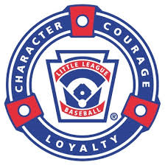 Qualified Safety Plan Requirements
- League Safety Officer: Mike Reese on file with Little League Headquarters.
- Preston Little League will distribute a paper copy of this safety manual to all Managers/coaches, league volunteers and the district Administrator.
- Emergency Phone Number: 911
Preston County Police Emergency 304-329-1611
Local Fire Departments Bruceton 304-379-3171
Kingwood 304-329-0101
Terra Alta 304-789-6660
Tunnelton 304-568-2600
Reedsville 304-864-6741
- This list will be posted in the concession area and dugout areas.
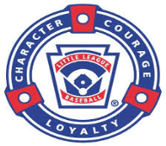 ASAP PLAN PAGE 2
Emergency Phone Numbers:

League President: Rob Lowe 304-692-6410
League VP: James Sanders 304-826-6897
League Player agent: Lauren Larew 304-698-6308
League Treasure: Hillary Jenkins 304-376-1337
League Safety Officer: Mike Reese 304-904-5253

- This list will be posted in the concession area and dugout areas.

- The Preston Little League will use the official Little League Volunteer Application form to screen all of our volunteers.

- Fundamentals Training: April 17th & 18th at Preston High school, Coach John Chambers
At least one manager/coach from each team must attend the training. Every manager/coach will attend this training at least once every 3 years. Training dates, times and place will be E-mailed to the Preston Little League President and then sent out to the rest of the League.
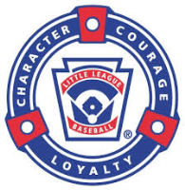 ASAP PLAN PAGE 3
- Frist Aid Training: March 20th ,27th April 3rd ,10th 2016 at PMH (Preston Memorial Hospital)
Preston Little League will require at least one manager/coach from each team to attend. Every manager/coach must attend this training once every 3 years. Training dates, times and place will be E-mailed to the Preston Little League President and then sent out to the rest of the League.

- Highly Recommended – research the concussion laws in West Virginia and educate all coaches / managers & league members. Look up Senate Bill No. 336

- Coaches will be required to walk/inspect the fields prior to practices and games. Umpires will also be required to walk the fields for hazards before each game.
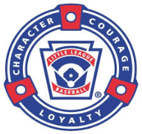 ASAP PLAN PAGE 4
- Preston Little League has completed our 2016 Facility survey.

- Concession Stand Safety:

- Menu shall be posted & approved by the safety officer and League President.
Our Concession Safety Procedures will be posted in the stand.

- Enclosed is a copy of the Preston Little League Concession Stand Safety Procedures.

- ASAP PLAN PAGE 5
- The League Safety Officer will inspect all equipment in the
Pre-season.

- Managers/Coaches will inspect equipment prior to each game.
- Umpires will be required to inspect equipment prior to each game.

- Implement Prompt Accident Reporting:
The League will use the provided incident tracking form the LL
website and will provide completed accident forms to the safety
officer within 24-48 hours of the incident. Please see copy of
accident reporting form @ http://www.littleleague.org

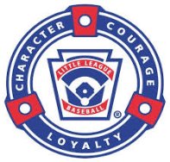 ASAP PLAN PAGE 6
- Each team will be issued an updated First aid kit and is a requirement to have it at every practice and game.

- Preston Little League will require ALL TEAMS to enforce ALL LITTLE LEAGUE RULES. Including Proper equipment for catchers.

- No On-deck batters
- Coaches will not warm up pitchers
- Bases will disengage on all fields

- Qualified Safety plan Registration form filled out and enclosed with
the safety plan.

ASAP PLAN PAGE 7
- League Player Registration Data or Player Roster Data and Coach
and Manager Data. This is our second year in little league and when complete we will send the information.

- League Player registration data or player Roster data and Coach and Manager data must be submitted via the little league data center at www.littleleague.org.

Mandatory requirement for an approved ASAP plan.

Facility and Field Inspection Checklist
Facility Name ___________________________________________
Inspector ____________________________________
Date ____________________ Time _______________
- Holes, damage, rough or uneven spots
- Slippery areas, Long grass
- Glass, rocks and other debris & foreign objects
- Damage to Screens, fence edges or sharp fencing
- Unsafe conditions around backstop, pitcher’s mound
- Warning track condition
- Dugouts conditions before and after games
- Make sure telephones are available
- Area’s around bleachers free of debris
- General Garbage clean-up
- Who’s in charge of emptying garbage cans
- Conditions or restrooms and restroom supplies
- Concession stand inspection
Notes / Hazards
________________________________________________________________________________________________________________________________________________________________________________________________________________________________________________________________________________________________________________________________________________________________________________________________________________________
Signature ____________________________________________________________________________________________

